IFP- ISV seris Interactive Flat Panel(V100)
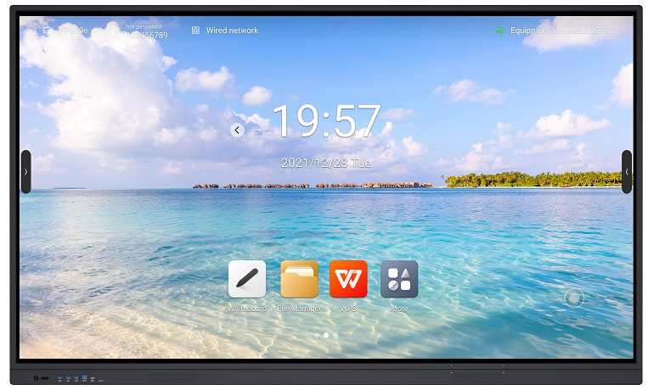
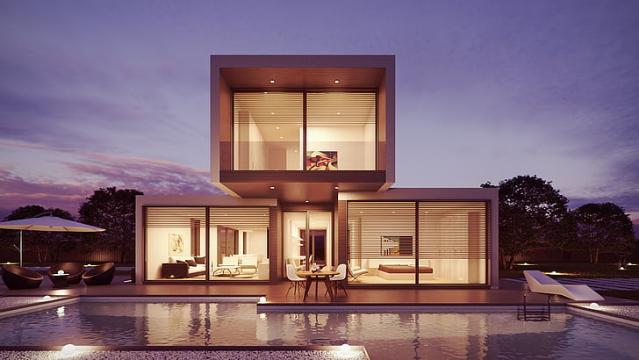
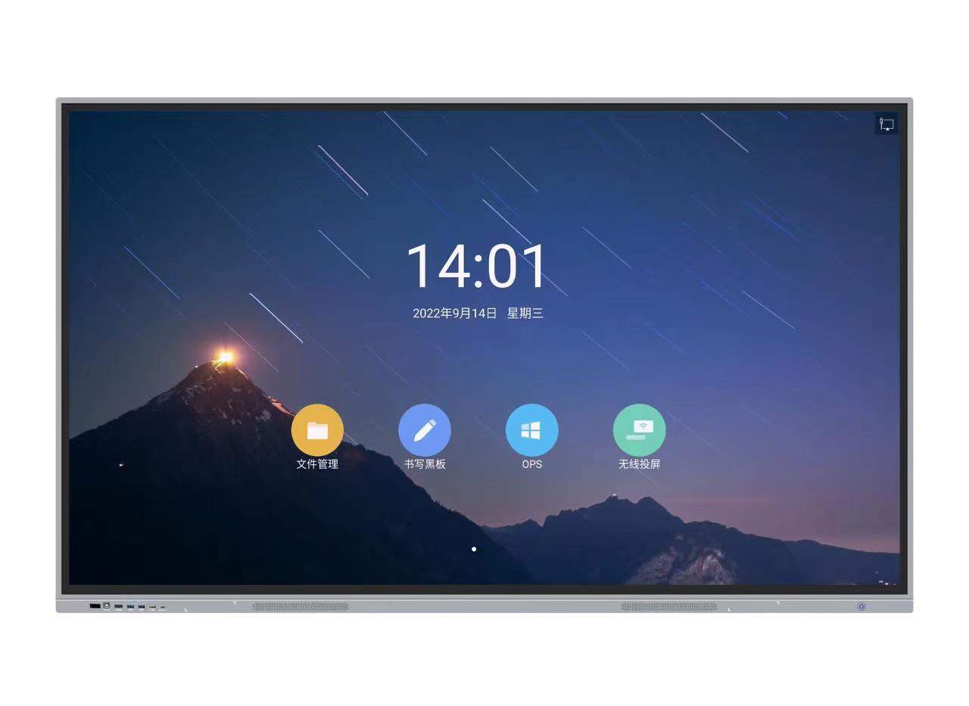

*The picture is only for reference*

- Zero gap Bonding technology,low parallax writing and wider viewing angles
- 4mm anti-glare toughened glass with high haze OC for clearer display against ambient light interference
- Light-sensitive brightness adjustment and DC dimming support (de-flashing) for a more eye-protection display
- 4K Ultra HD display ,support full channel 4K UI display
- Front Type C*1+ USB3.0*3 + HDMI in*1+USB touch*1, supports switching with channels
- Support for Wireless projection, quad/nine screen with miracast
- ±1mm High precision infrared touch control for smooth writing
- Supports dual pens and dual colour displays for easy multi-person collaboration
- Wi-Fi6(Optional), dual-band 2.4G/5G, AP+STA operating mode
- One network support, Android and OPS
- Support network sharing
- Split screen ,parallel tasks and wider scenes
- Eye protection, lock screen, touch lock and other tools.

Product parameters
Panel | LCD Size |  | 55”, 65”, 75”, 86”, 98”
Panel | Model No. |  | ISV55A  ISV65A  ISV75A  ISV86A  ISV98A
Panel | Type of Panel |  | IPS/VA
Panel | Respond Time |  | 8ms
Panel | Visual Ratio |  | 16:9
Panel | Max Visual Area |  | 55”:1209.6(H)×680.4(V)mm  65”:1428.48(H)×803.52(V)mm  75”:1649.664(H)×927.936(V)mm  86”:1895.04(H)×1065.96(V)mm  98”:2158.848(H)×1214.352(V)mm
Panel | Resolution |  | 3840（H）×2160（V）
Panel | Pixel pitch |  | 55”:0.315mm x 0.315mm  65”:0.372mm x 0.372mm  75”:0.4296mm ×0.4296mm  86”:0.4935 mm x 0.4935 mm  98”:0.5622 mm x 0.5622 mm
Panel | Frequency |  | 60Hz
Panel | Display Colors |  | 1.07B (10bit)
Panel | Color saturability |  | 72%
Panel | Contrast ration(Typ) |  | 1100:1(IPS),4000:1(AV)
Panel | Viewing Angle |  | 178°(H/V)
Panel | Light source |  | DLED
Panel | Brightness |  | 350cd/m2
Panel | Life Span |  | ≥30000hrs
Audio-video  parameters | Speaker | Soundtrack | 2.0
Audio-video  parameters | Speaker | Power | 2×20W
Audio-video  parameters | Speaker | woofer: | 20W(Optional)
Touch parameter | Touch specifications |  | Non-contact infrared sensing technology
Touch parameter | Support Systems |  | Windows10/Windows8/Windows7/Windows XP/Android/Linux/Mac OS X/Chrome
Touch parameter | Touch Points |  | 20 Points Touch
Touch parameter | Min.Identifier |  | 2mm
Touch parameter | Input mode |  | Opaque object (finger, pen, etc)
Touch parameter | Respond time |  | ≤10ms
Touch parameter | Touch depth |  | ±1mm
Touch parameter | Writing height |  | ≤3mm
Touch parameter | Writing display |  | Single Stylus pen two-colour
Touch parameter | Output coordinates |  | 32767 (W) ×32767(D)
System | System Version |  | Android 12.0(Will upgrade to Android 14 at beginning of 2024)
System | CPU |  | Octa-core A55 (A55*8)
System | GPU |  | Mali-G52MP4
System | RAM |  | 4GB(Maximum 8G)
System | ROM |  | 32GB(Maximum 128G+1TB TF card)
Wireless | Bluetooth | Version | 5.0
Wireless | Bluetooth | Working Frequency | 2.4GHz
Wireless | Bluetooth | Working Distance | 0~10m
Wireless | Wi-Fi | Version | 802.11ac/b/g/n/a/ax
Wireless | Wi-Fi | Working Frequency | 2.4GHz/5GHz
Wireless | Wi-Fi | Working Distance | 0~10m
I/O Interface | HDMI IN |  | 2(HDMI 2.0）
I/O Interface | HDMI OUT |  | 1(Optional)
I/O Interface | DP IN |  | 1(Optional)
I/O Interface | VGA IN |  | 1
I/O Interface | Type C Full Functions |  | 1(Optional)
I/O Interface | USB 2.0 |  | 1(Android）
I/O Interface | USB 3.0 |  | 1(Follow）
I/O Interface | TOUCH |  | 1
I/O Interface | AUDIO IN |  | 1
I/O Interface | Line OUT |  | 1
I/O Interface | RS232 |  | 1
I/O Interface | MIC IN |  | 1(Optional)
I/O Interface | TF Card |  | 1
I/O Interface | LAN IN |  | 1
I/O Interface | LAN OUT |  | 1(Optinal)
Front Interface | USB3.0 |  | 2(or 3)
Front Interface | TOUCH USB |  | 1(USB2.0）
Front Interface | HDMI IN |  | 1(HDMI 2.0）
Front Interface | Type C |  | 1
Power | Voltage |  | 100-240V～ 50/60Hz 4A
Power | Max. power consumption |  | 350W
Power | Standby power consumption |  | ≤0.5W
Structure | Bare dimension |  | 55”:1263*783.5*84.7mm  65”:1486*909*89.9mm  75”:1707*1034*90.6mm  86”:1953.96*1173.62*90.6mm  98”:2232*1329.4*108.1mm
Structure | Packing dimension |  | 55”:1430*(928+120)*236mm  65”:1663*(1035+120)*243mm  75”:1880*(1160+110)*285mm  86”:2190*(1480+120)*355mm  98”:2505*(1623+120)*450mm
Structure | Machine+wall mount thickness |  | 118mm
Structure | VESA hole site |  | 800×400mm
Structure | Wall mounting screw specifications |  | M8×25mm
Structure | Net weight |  | 55”:39.8kg  65”:39.8kg  75”:54.51kg  86”:62.78g  98”:135kg
Structure | Gross weight |  | 55”:47.19kg  65”:54.5kg  75”:71.14kg  86”:80.33kg  98”:210kg
Accessories | Power cord |  | ×1
Accessories | Stylus pen |  | ×2
Accessories | Wall mount |  | ×1
Accessories | Operation manual |  | ×1
Environment | Working temperature |  | 0℃~40℃
Environment | Working humidity |  | 10%~90%RH
Environment | Storage temperature |  | -20℃~60℃
Environment | Storage humidity |  | 10%~90%RH
Environment | Working Elevation |  | <5000m

Six product view
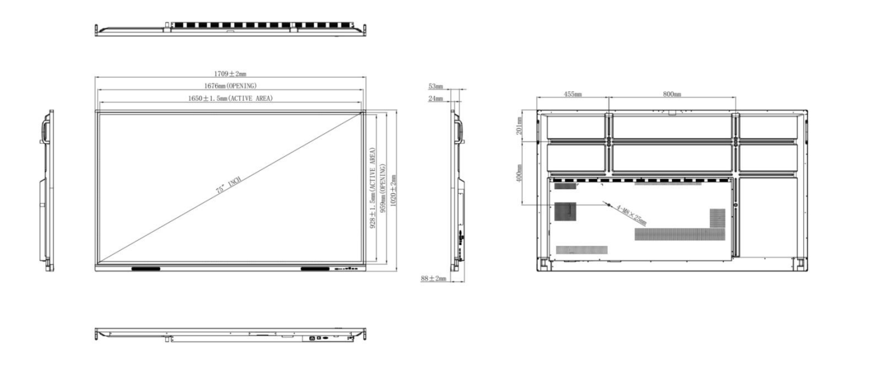

*Disclaimer
Due to product configuration and manufacturing process, actual body size/body weight may vary, please refer to the actual product.
The product images in this specification are for illustrative purposes only. The actual product effect (including but not limited to appearance, colour and size) may vary slightly.
Please refer to the actual product.
In order to provide accurate specifications as far as possible, the text expressions and pictures in this specification may be adjusted and revised in real time.
The product specification may be adjusted and revised in order to match the actual product performance and specifications.
In the event that such changes and adjustments are necessary, no special notice will be given.

